CIS8695

**Homework I**

**What to Turn In:**

Please write your answers and paste the required results/reports into **an MS Word file**. **Note:** Please do NOT submit any other file format because it will cause grading inconvenience. Failing to submit an incorrect file format will cause the loss of homework grades! You can use screenshots if it is convenient for you.

**Problems**

Homework problems are all from the textbook. For your convenience, the pictures of the problems are also attached to the document at the end. Datasets are provided on iCollege.

**Problem 1**. (Linear Regression). Look at Problem 1 in Chapter 6 of the Textbook. (A picture of the problem is attached below). (You can directly load the data from the dmba package, named BostonHousing.csv).

**Problem 2**. (Logistic Regression). Look at Problem 1 in Chapter 10 of the Textbook. (A picture of the problem is attached below). Note for part (b): Please write down your calculation equations. (You can directly load the data from the dmba package, named banks.csv).

**(Optional)** You are also encouraged to try Ridge Regression and Lasso for both problems, and you will receive bonus points.

**Problem 3.** (Decision Tree). Look at Problem 1 in Chapter 9 of the Textbook. (A picture of the problem is attached below). (You can directly load the data from the dmba package, named eBayAuctions.csv).

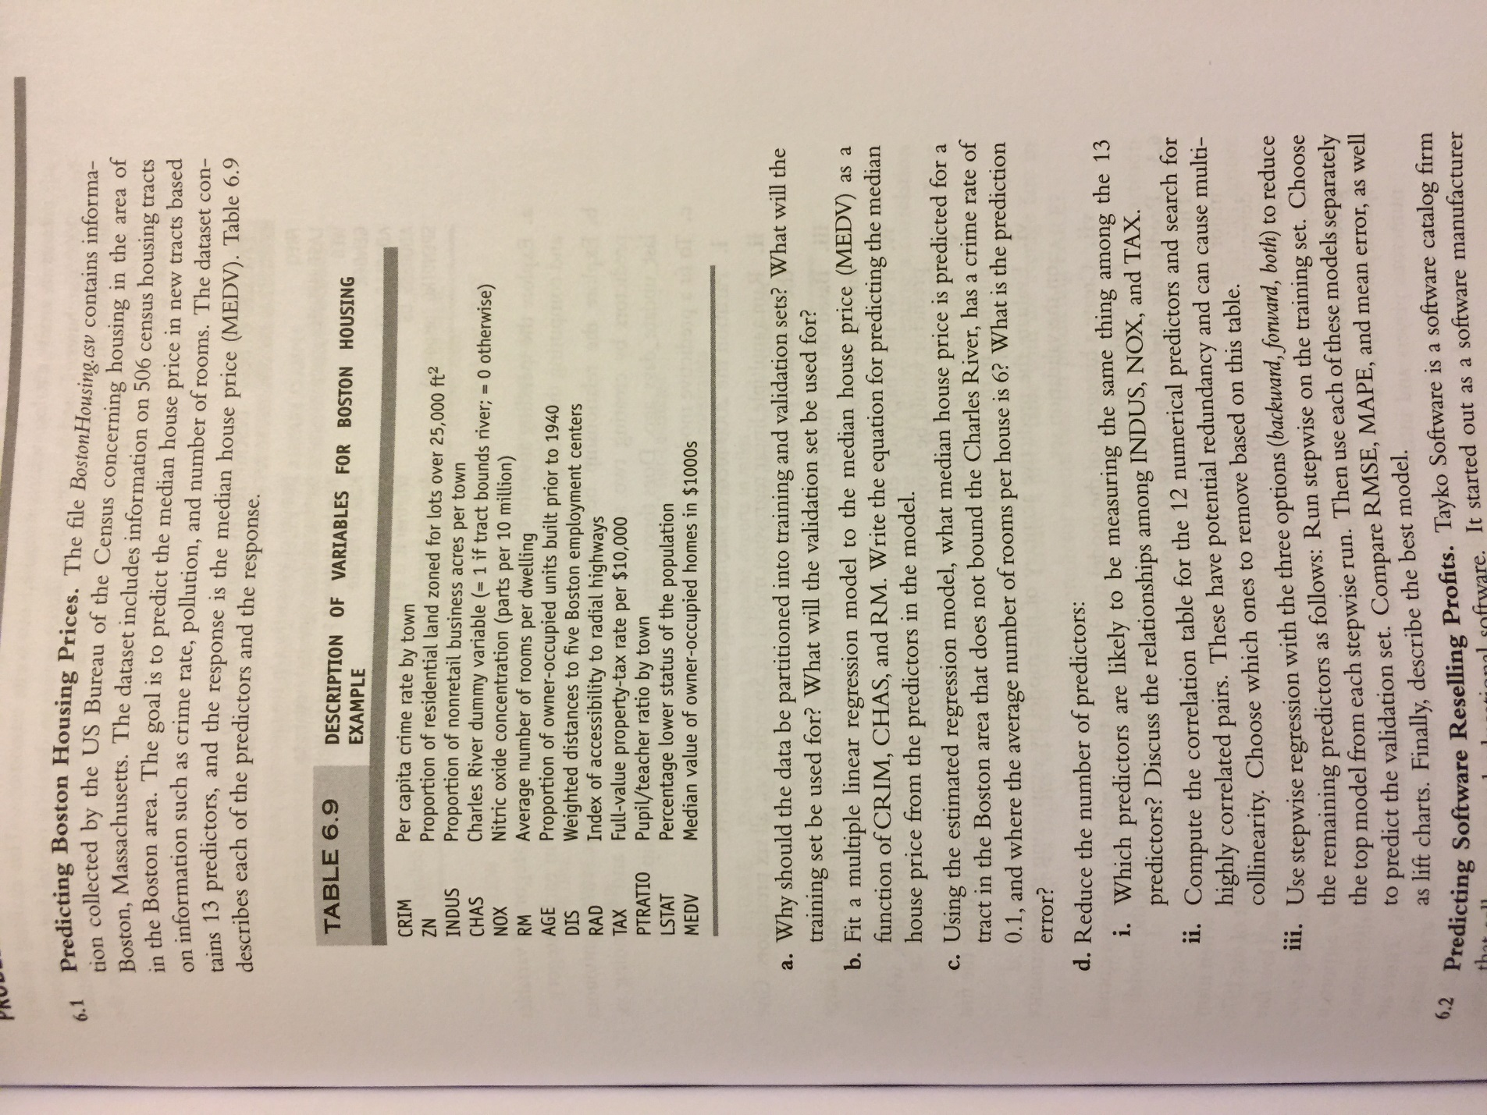

Problem2.

Problem3.

